Thought Force on acquiring a computer, printer, and projector for the Area Delegate
Created On: 08/20/2018

Members: Shannon S., Kay S., and Carol S.

Need: The Area is inquiring about purchasing a computer, printer, and projector for the Area Delegate to use during their 3 year term in order to better serve their Area.

What we know:
- The delegate travels around the area giving presentations.
- The delegate travels to World Service Conference with printouts of information that was sent electronically.
- There is a need for information to be collected and stored in a central location for quick retrieval.
- When the delegate give presentations, printed handouts are given, along with a PowerPoint presentation using a laptop and a projector.

Hardware Requirements are:
- Laptop - the delegate needs to be able to travel with computer. The laptop needs are:
  - Travel Case
  - Wireless USB Mouse
  - CD-Rom/DVD-RW Drive
  - WiFi capability
  - Access to Google Docs/Sheets/Slides, AFG Connects, etc.
  - HDMI port - For use with the projector.
  - Virus Software
- Printer - The delegate needs to be able to print out handouts for their presentations. The printer needs are:
  - Wireless
  - Cartridges
  - Scanner
- Projector - The delegates needs their own projector for giving presentations. The projector needs are:
  - Wireless
  - Remote Control
  - Carrying Case
- Maintenance Items are:
  - Printer Ink Cartridges - 3 years worth
  - Virus Software - 3 year subscription

Below are approximate costs for the items needed:

Dell.Com
Laptop- Inspiron 15 3000 Series - $399 - Premium Support 3 years = $179.99, Virus Software 3 years = $69.99
- Inspiron 15 3000 Series
- Processor
  - 6th Generation Intel® Core™ i3-6006U Processor (3MB Cache, 2.00 GHz)
- Operating System
  - Windows 10 Home 64-bit English
- Memory
  - 4GB, 2400MHz, DDR4; up to 16GB (additional memory sold separately)
- Hard Drive
  - 1TB 5400 rpm Hard Drive
- Video Card
  - Intel® HD Graphics 520
- LCD
  - 15.6-inch HD (1366 x 768) Anti-Glare LED-Backlit Display
- CD ROM/DVD ROM
  - Tray load DVD Drive (Reads and Writes to DVD/CD)
- Support
  - 3 Years Premium Support - With purchase is $179.99
- Security Software
  - McAfee LiveSafe Consumer 36 Month Subscription - With purchase is $69.99
Printer - Epson Expression Premium XP-640 Inkjet Printer -Multifunction Wi-Fi - $79.99
- Limited Time Offer : Save $70 (Note: This discount is with the purchase of the PC only) (regular price - $149.99)
- Wireless, Scanner, Copier, Printer
- Cartridge costs $12.99 - Epson.com
Projector - LG MiniBeam PH150G Projector - HD Projector - $299
- Base
  - LG MiniBeam PH150G Projector - HD Projector
- Wireless
- Remote
Case - Dell Urban Backpack - 15 - $24.99
- Limited Time Offer : Save $15 (With purchase of PC, regular price is 39.99)
Wireless Mouse - Dell Wireless Travel Mouse - WM126 - $13.99
- Limited Time Offer : Save $6 (With purchase of PC, regular price is $19.99

Total Purchase Cost from Dell is: $1,117.90
Similar Items from Staples.com
Laptop- Notebook features 7th gen AMD E-series E2-9000e dual core 1.5 GHz (up to 2 GHz turbo) processor, 4GB (1 x 4GB) 2133 MHz DDR4 SDRAM and 1TB 5400 RPM SATA HDD. $409.99
The HP® 15-BW061NR 15.6" Notebook has AMD E-series E2-9000e dual core 1.5 GHz processor for ultimate performance. The 4GB DDR4 SDRAM helps in multitasking and has 1TB HDD for vast data collection. It features AMD Radeon R2 graphics for editing images, videos and 3D applications. It supports IEEE 802.11b/g/n 1x1 WLAN, Wi-Fi and 10/100/1000 GbE LAN technologies for wireless web browsing. The Notebook has USB 2.0, 2 x USB 3.1, HDMI and RJ-45 interfaces for external connection. It works on Windows 10 Home OS.
- Features 7th gen AMD E-series E2-9000e dual core 1.5 GHz (up to 2 GHz turbo) processor with 1MB cache memory
- Has 4GB (1 x 4GB) 2133 MHz DDR4 SDRAM with 260-pin SO-DIMM socket
- Comes with 1TB 5400 rpm SATA HDD
- Performs on 64-bit Windows 10 Home operating system
- Has 15.6" HD (1366 x 768) SVA BrightView WLED-backlit widescreen LCD display
- Features AMD Radeon R2 graphics with up to 2118MB total memory
- Provides IEEE 802.11b/g/n 1x1 WLAN, Wi-Fi and integrated 10/100/1000 GbE LAN connectivity
- Has USB 2.0, (2) USB 3.1 gen 1, HDMI, RJ-45 ports
- Has full size island-style keyboard with numeric keypad, multi-touch gesture support touchpad pointing device
- Comes with 3-cell 2.8 Ah, 31 Wh lithium ion battery with up to 6.75 hrs mixed usage and up to 4.75 hrs video playback life
- Dimensions: 0.94"H x 14.96"W x 9.99"D, weight: 4.52 lbs.
- Power supply: 45 W AC adapter
- Audio: HD audio with stereo speakers, headphone out/microphone in combo jack
- Has front facing HP TrueVision HD webcam
- Optical drive: DVD-writer
- Media card reader: Multi-format SD
- Security: Kensington MicroSaver lock slot
- Software: HP Recovery Manager, HP Support Assistant, HP Games Powered by WildTangent, HP ePrint, Netflix, HP CoolSense, McAfee LiveSafe
- Includes Notebook, battery, AC adapter
- Meets Energy Star and EPEAT Silver standards
- Comes with 1 year limited hardware warranty
Support - 2 year warranty - $82.29
Mouse - Microsoft® Wireless Mobile Mouse 1850, USB Wireless Mouse, Wool Blue (U7Z-00011)- $12.00
Virus Software - Norton AntiVirus Basic for Windows (1 User) [Product Key Card] - $24.99 ( 1 year subscription) 3 years = $74.97
Case - 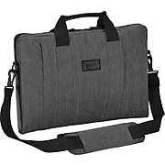
Targus® 16" CitySmart Sleeve with Strap, Gray
Item : 383757 / Model : TSS59404US
(44)
- Fits most laptops up to 16"
- Durable, nesting handles for ease of travel as well as a removable padded shoulder strap for hands-free carrying
- Padded and scratch resistant laptop compartment along
$28.99
Printer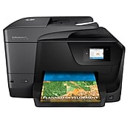
HP OfficeJet Pro 8710 All-in-One Inkjet Printer
Item : 2091478 / Model : M9L66A#B1H
(431)
- Printer type: All-in-one color printer. Main functions of this HP color printer include copying, scanning, faxing, and wireless printing.
- Print Technology: HP Thermal Inkjet. Resolution: Black (best): 1200 x 1200 rendered dpi; Color (best): Up to 4800 x 1200 optimized dpi on HP Advance Photo Paper 1200 x 1200 dpi input
- Print speed: Black (ISO): Up to 22 ppm; Color (ISO): Up to 18 ppm; First Page Out Black: As fast as 9 sec; First Page Out Color: As fast as 10 sec; Black (Draft): Up to 35 ppm; Color (Draft): Up to 35 ppm. Monthly duty cycle: Up to 25,000 pages.
$119.99 $199.99
Cartridges - $105.99 Black yields up to 2,000 pages/Color yields up to 700 pages

Projector - 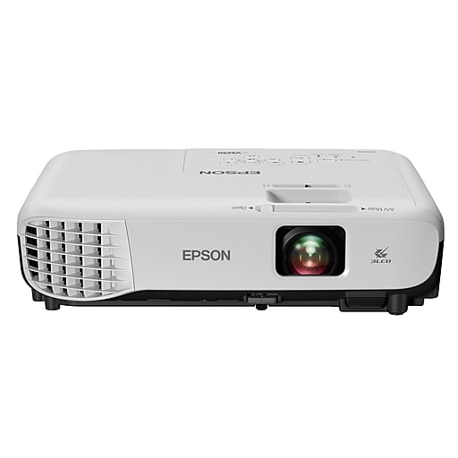
Epson VS250 SVGA 3LCD Projector, White - $299.99
Total for Staples.com - $1084.23*
* (This only includes 1 year virus protection add $50.00 for 2 more years = $1,028.24 - Ink Cartridges for 2000 pages included)

Notes: Can purchase less expensive projectors, but my guess is you will get what you pay for.
Take Away - Total Cost is approximately $1000.00 to purchase a laptop, printer, projector, wireless mouse, virus software, ink cartridges, and warranty coverage. Can exclude optional items such as wireless mouse and warranty coverage and save about $100.00.
Future Delegates -
The goal is to be able to pass on all these hardware items to the next Delegate and have them function for an additional 3 years. We anticipate the needs for those additional three years as follows:
- Virus Software - Additional 3 years = $74.97
- Printer Cartridges - Approximate Cost $110. Based on 700 pages.
There is no warranty or technical support after the initial 3 year purchase. May be wise to budget for $500 support expense for the next 3 years.

